SISTER NIVEDITA MONTESSORY SCHOOL
NURSERY
PRACTICE 3 PAGES
HINDI
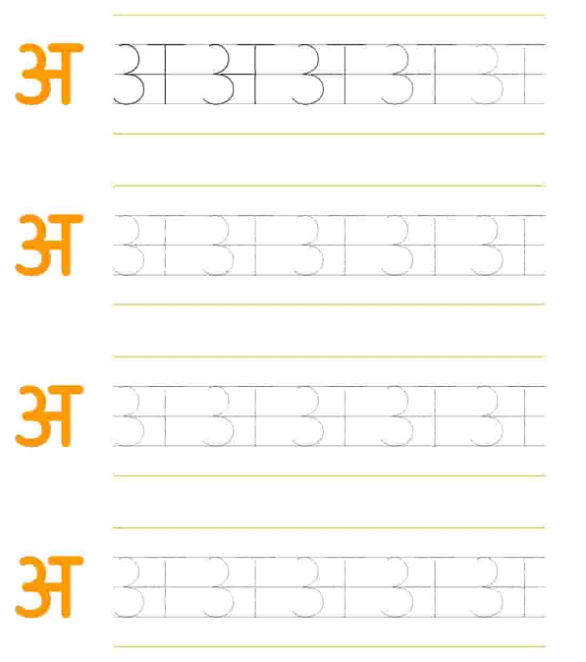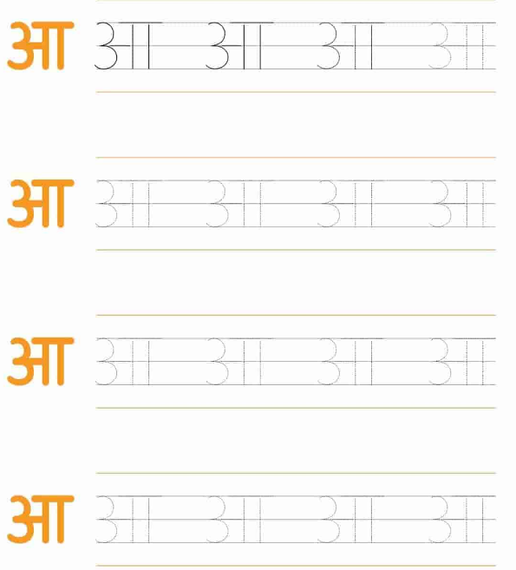

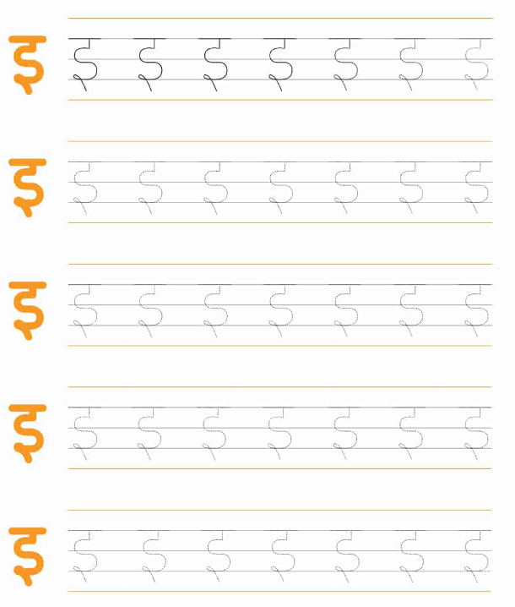
WRITING PATTERN EX BOOK 1- COMPLETE PG 19 & 20.
WRITING PATTERN EX BOOK 2 - COMPLETE PG 7.

DRAWING
COLOUR IT.
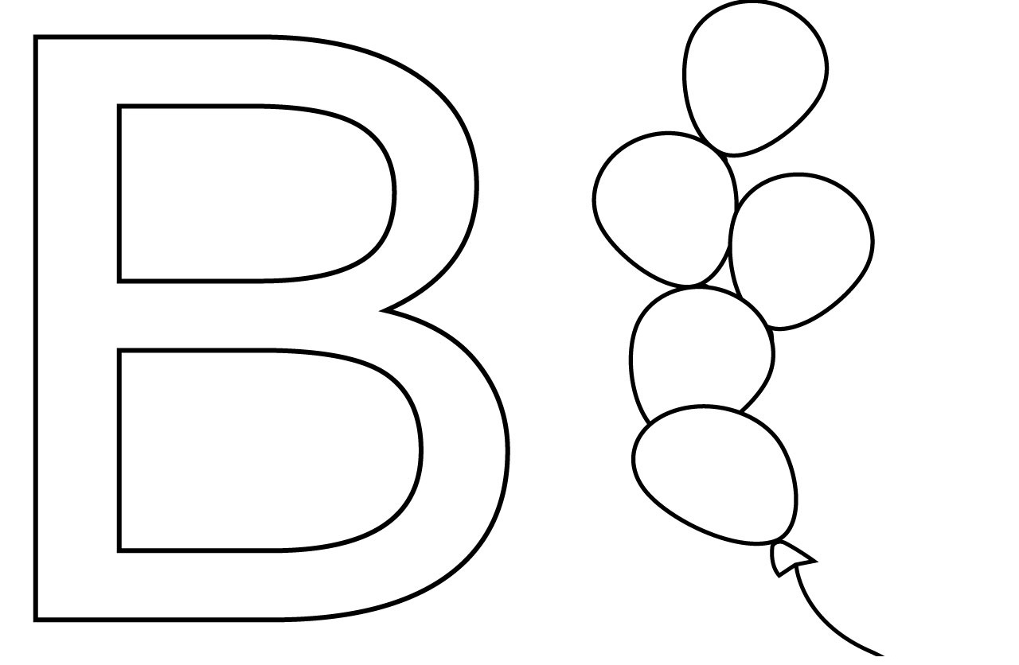

MATHS
PRACTICE NUMBER 1 (ONE)- GO- OVER
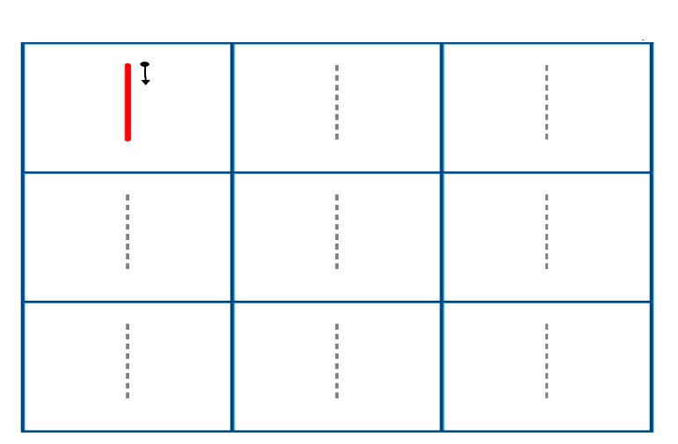
PRACTICE NUMBER 2 (TWO)- GO –OVER PRACTICE NUMBER 3 (THREE)- GO -OVER
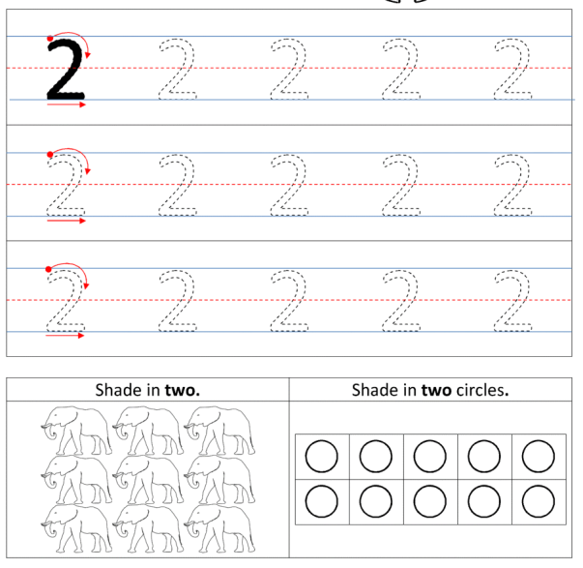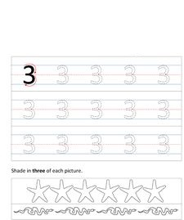
PRACTICE NUMBER 4 (FOUR)- GO OVER.
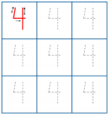

PUT YOUR FINGER AND READ FROM BOOK.

“A FOR APPLE” TO “D FOR DOLL”.
“1” TO “30”
LEARN IT
WHAT IS YOUR NAME?
WHAT IS YOUR FATHER’S NAME?
WHAT IS YOUR MOTHER’S NAME?
WHERE DO YOU LIVE?
1 HINDI & 1 ENGLISH RHYMES FROM FILE.

