SISTER NIVEDITA MONTESSORY SCHOOL
NURSERY
PRACTICE 3 PAGES
HINDI
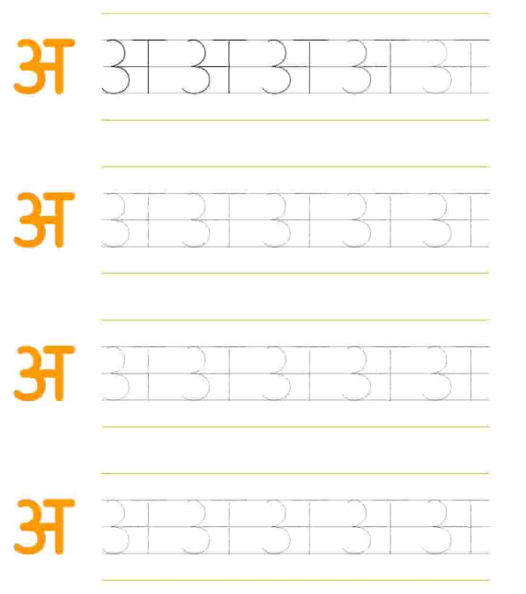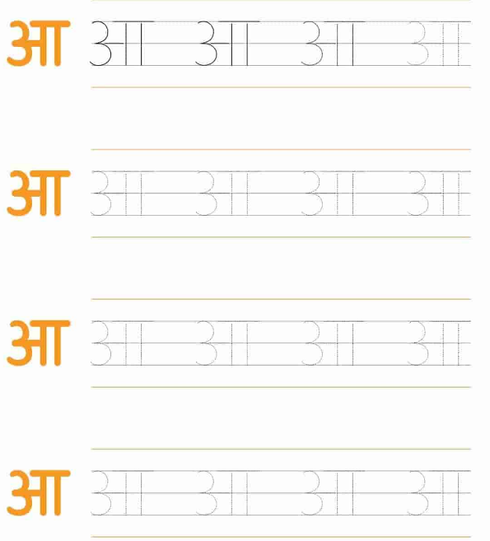

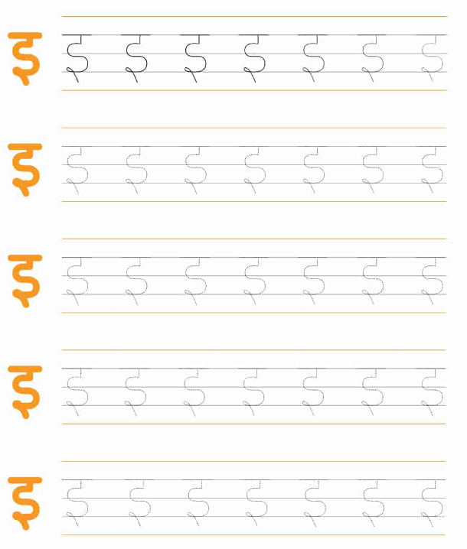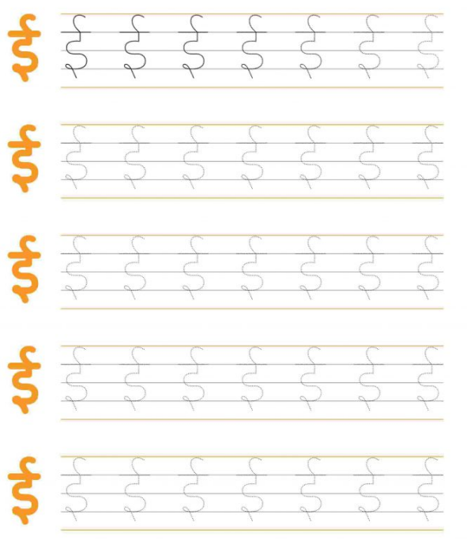
WRITING PATTERN EX BOOK 1- COMPLETE PG 21 & 22.
WRITING PATTERN EX BOOK 2 - COMPLETE PG 8.

DRAWING
COLOUR IT.

MATHS
PRACTICE NUMBER 1 (ONE)- GO- OVER
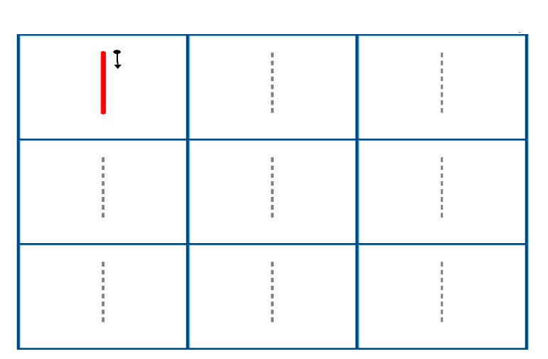
PRACTICE NUMBER 2 (TWO)- GO –OVER PRACTICE NUMBER 3 (THREE)- GO -OVER
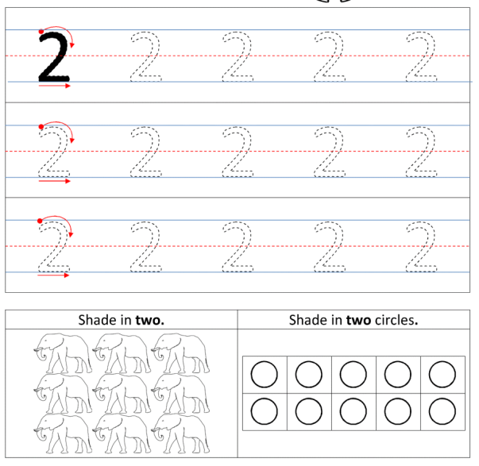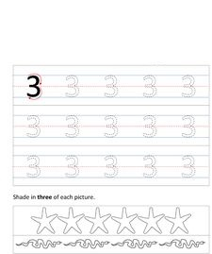
PRACTICE NUMBER 4 (FOUR)- GO OVER.
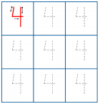

PUT YOUR FINGER AND READ FROM BOOK & IDENTIFY.

“A FOR APPLE” TO “D FOR DOLL”.
“1” TO “30”
LEARN IT
WHAT IS YOUR NAME?
WHAT IS YOUR FATHER’S NAME?
WHAT IS YOUR MOTHER’S NAME?
WHERE DO YOU LIVE?
1 HINDI & 1 ENGLISH RHYMES FROM PORTION.

