SISTER NIVEDITA MONTESSORY SCHOOL
CLASS- II
MATHS- SOLVE & PRACTICE.
PAGE NO- 4,5,6,& 7 FROM JUNIOR MATHEMATICS BOOK.
SCIENCE-
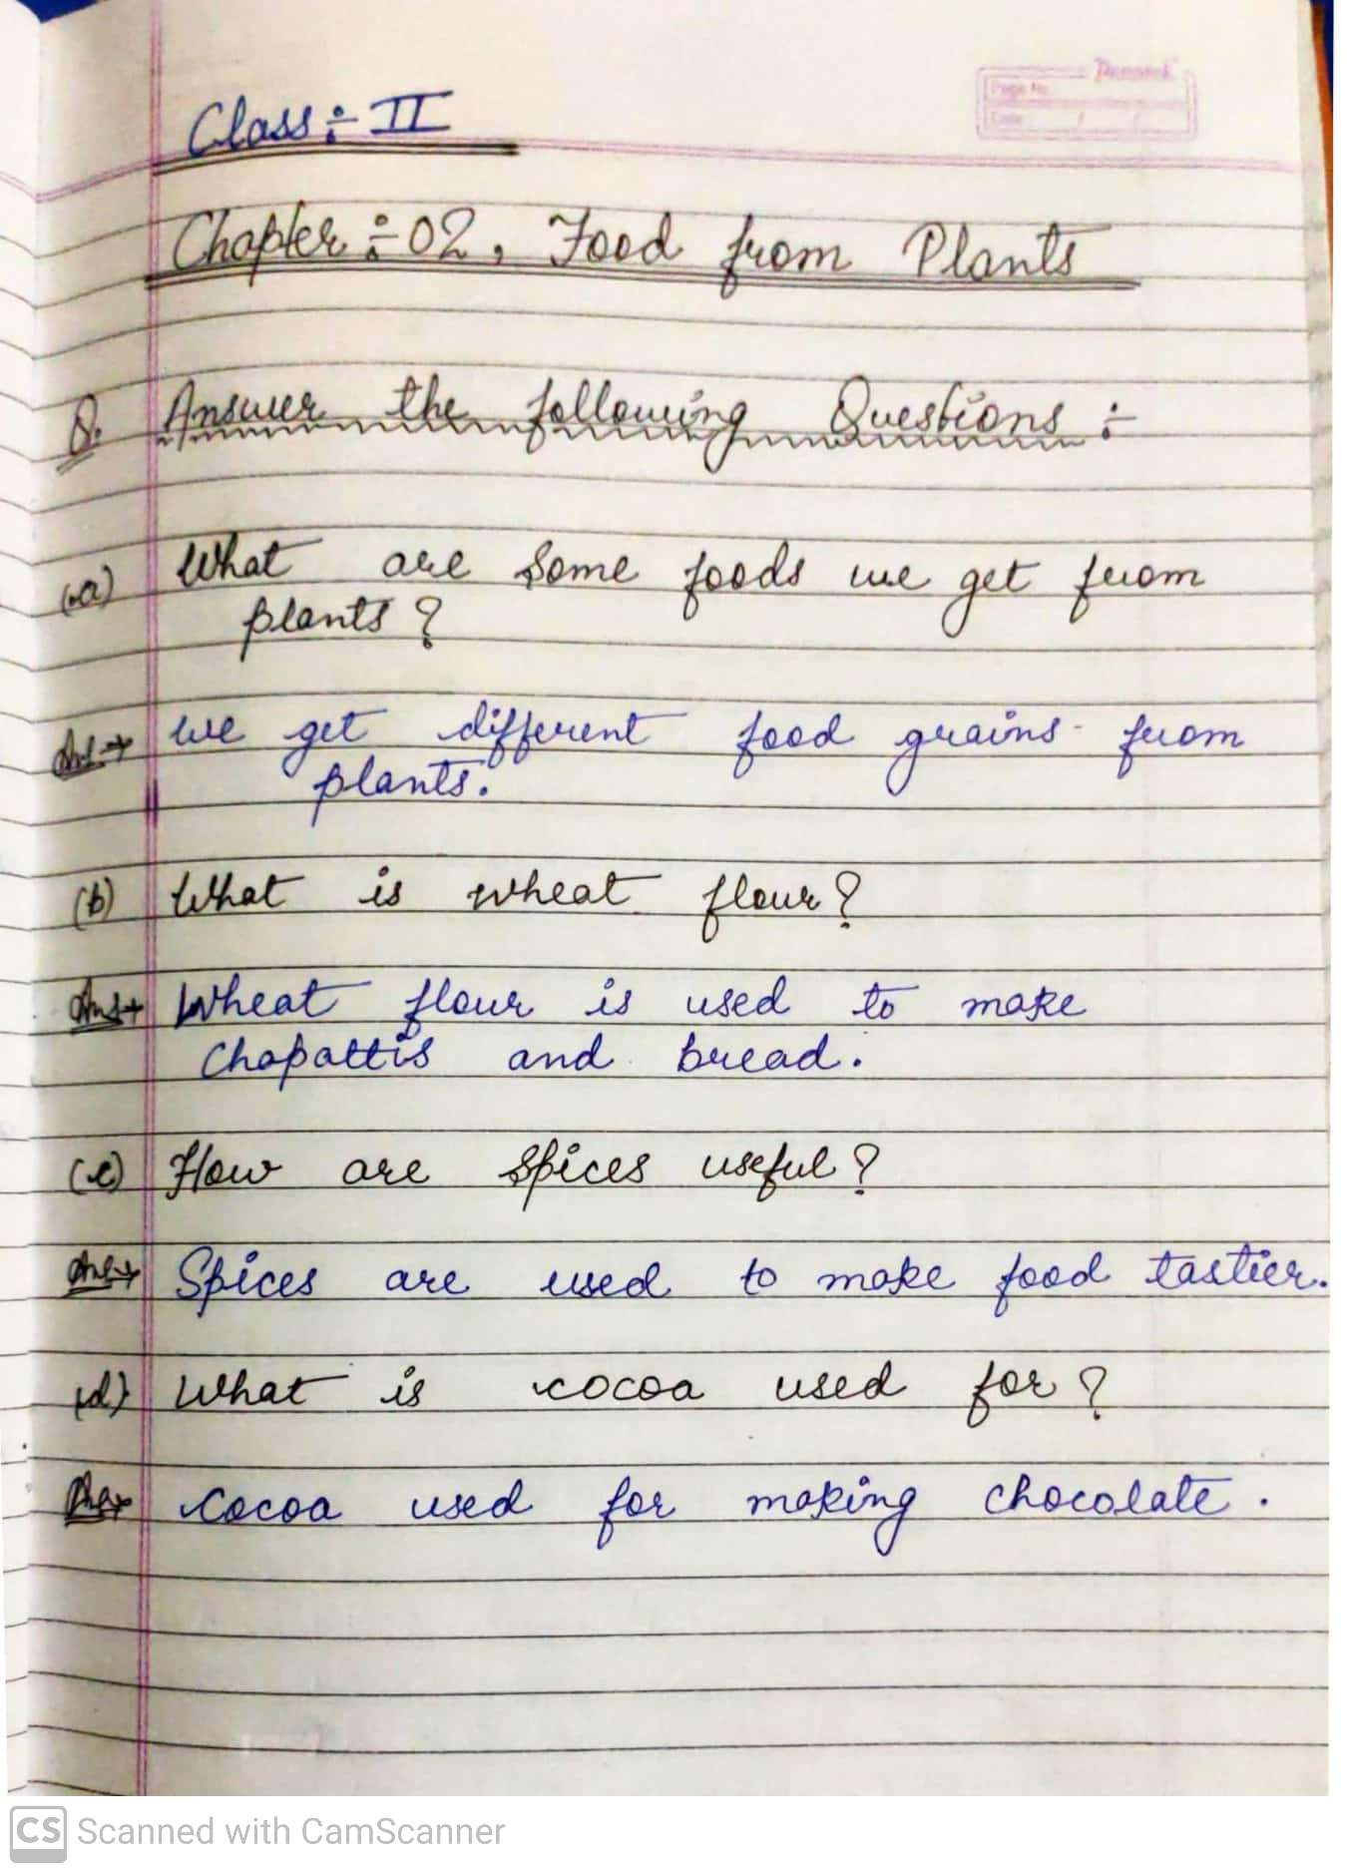

HINDI-
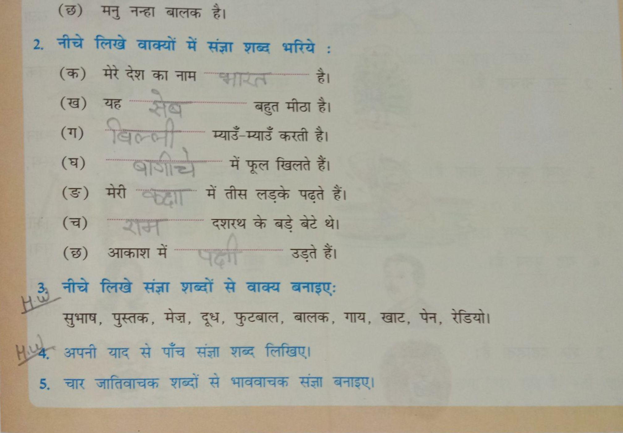

G.K-
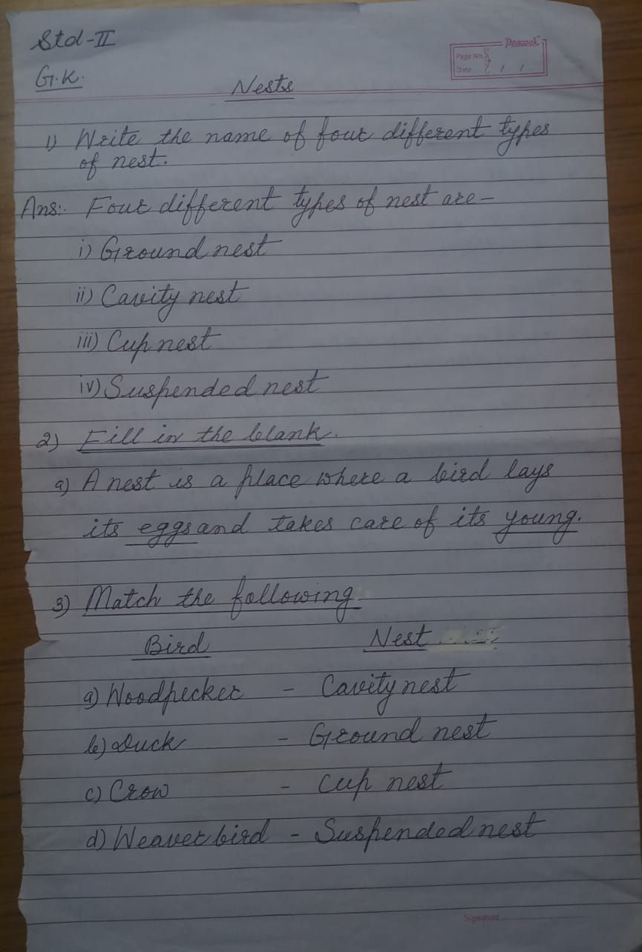

ENGLISH-
