SISTER NIVEDITA MONTESSORY SCHOOL
DRAWING & HANDWRITING
CLASS – IV
COMPLETE PG.NO- 3,4,&5 IN CURSIVE WRITING BOOK.
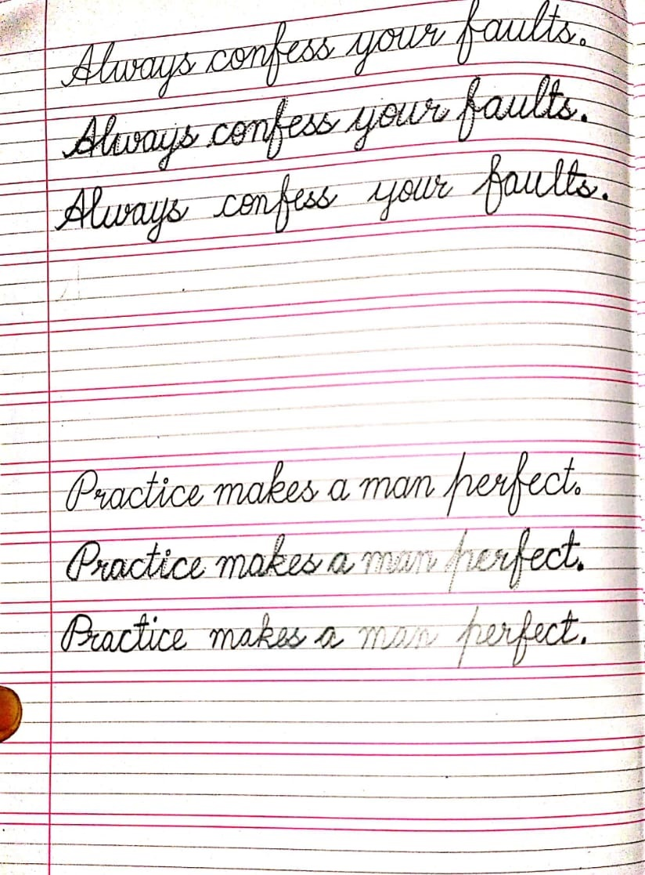
COMPLETE THE PICTURE &COLOUR IT.
