SISTER NIVEDITA MONTESSORY SCHOOL
CLASS- II
G.K
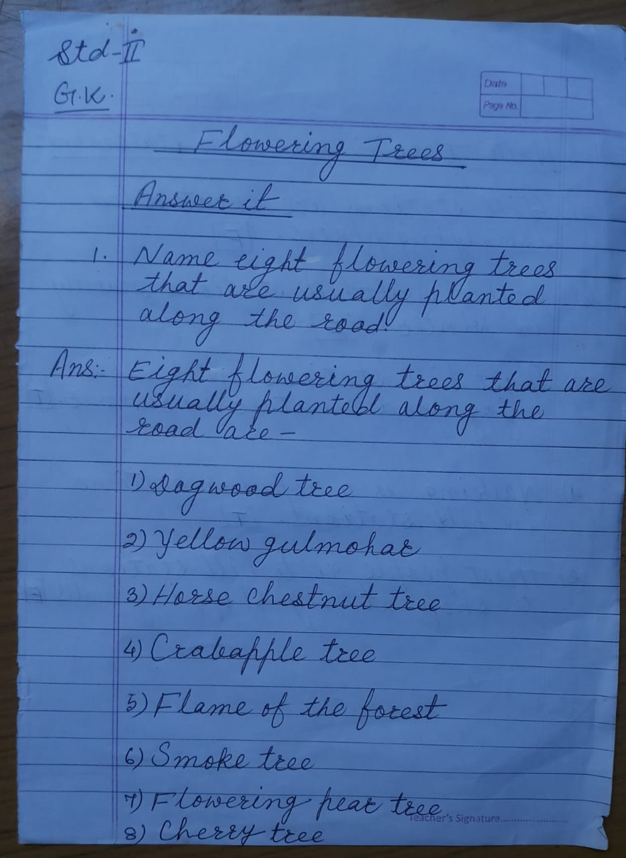

हिन्दी
याद करे और लिखे –
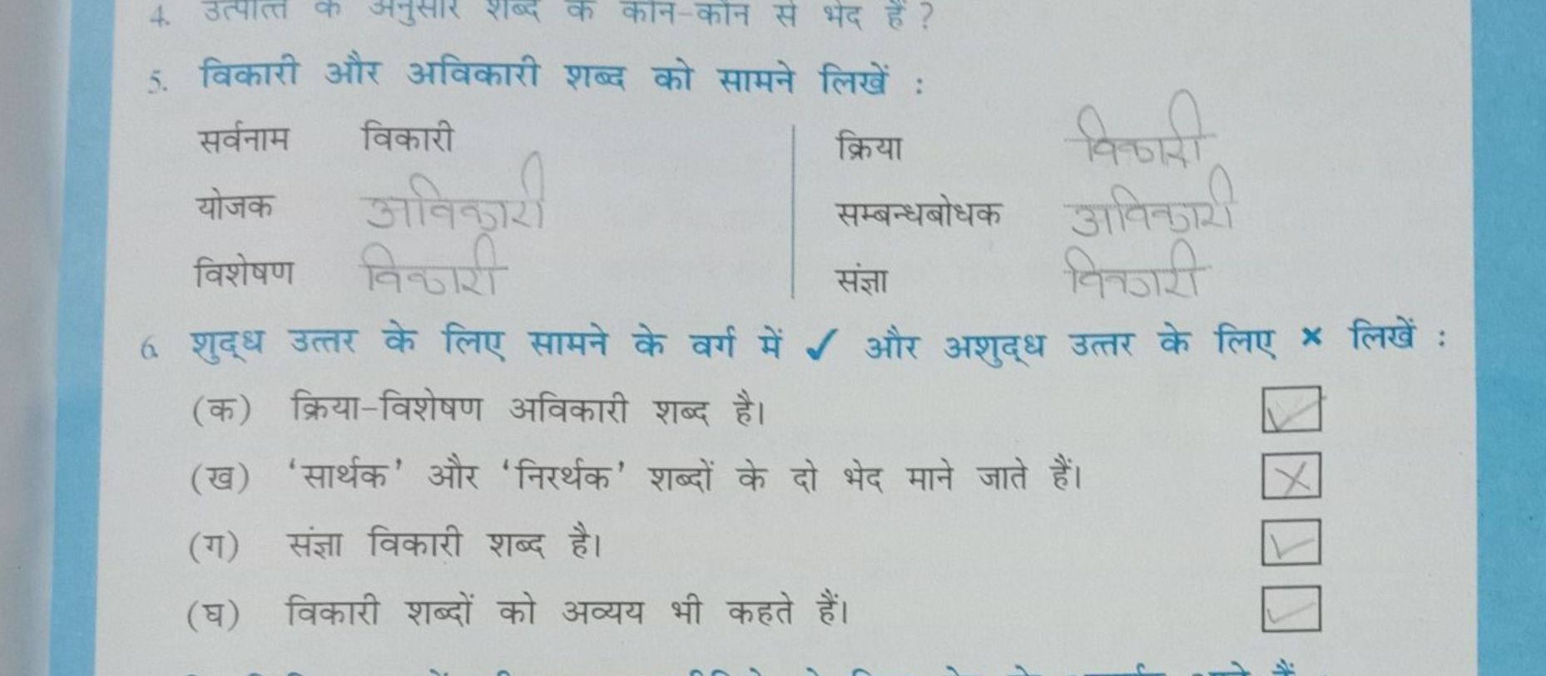

SCIENCE

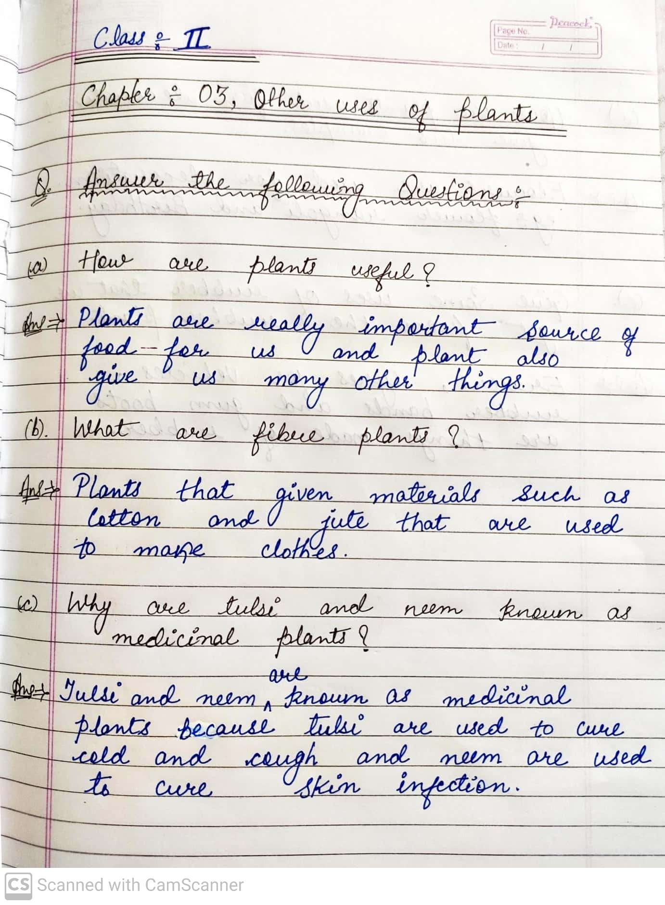
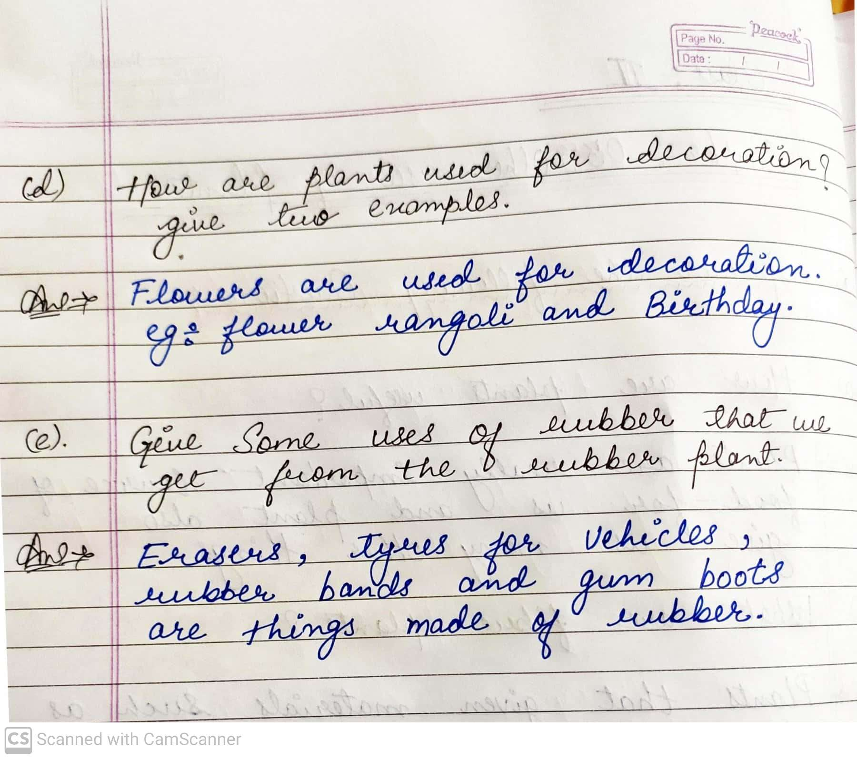

MATHS
COMPLETE PAGE NO- 12,13,14 & 15 SOLVE IT IN NOTEBOOK.

