SISTER NIVEDITA MONTESSORY SCHOOL
CLASS – L.K.G
ENGLISH
CAPITAL\SMALL “D/d”
PRACTICE 3 PAGES
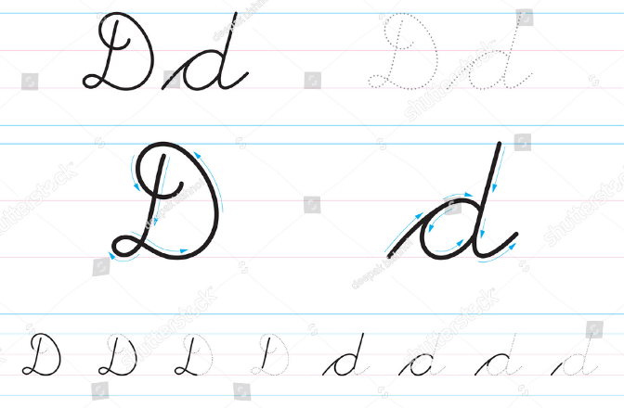
PRACTICE A/a, B/b & C/c.
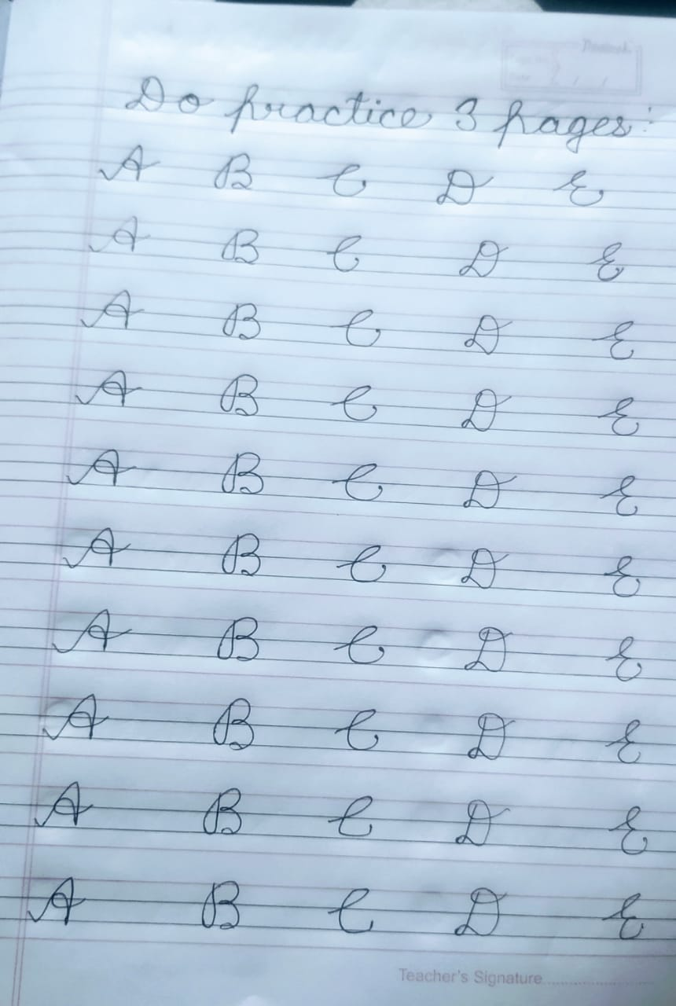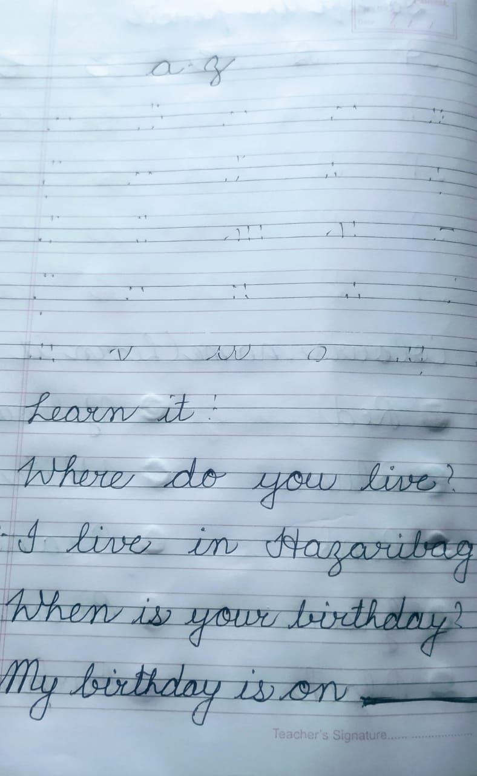

MATHS
